Author: Rhoda Woets

[r.woets@vu.nl](mailto:r.woets@vu.nl)

Word count: 997

Achimota School

The majority of Ghana’s modern art pioneers received their art education at Achimota School in the Gold Coast, now Ghana. Achimota School contributed in an important way to the formation of Modern Art in Ghana. Students trained at the Achimota Teacher Training Department spread new ideas about art and art education at schools where they later worked. The discursive fields in which Modern visual artists came to discuss their work, following their independence, were embedded in a colonial past in which European art teachers at Achimota had positioned African tradition as both preceding and opposed to modernity. Just like the art teachers at Achimota, Modern artists deeply admired ‘primitive art’ and considered local art forms to have roots stretching into a timeless past. Modern artist were in this regard influenced by their education at Achimota School, as well as by nationalist ideologies that fostered pride in an African cultural past. Among the school’s most notable students are Oku Ampofo (1908-1998), Emmanuel Asihene (1915-2001), Amon Kotei (1915-2011), Saka Acquaye (1915-2007), Kofi Antubam (1922-1964), Theodosia Akoh (1922) and Vincent Kofi (1923-1974).

The teaching methodology of the European heads of the art department in Achimota was grounded in a growing admiration for African tradition and African primitive art during the late colonial period. Their way of looking at art was, furthermore, influenced by the Arts and Crafts Movement in Europe, which was characterized by a romantic view of crafts and called for an enhancement of their status.

Achimota School was officially opened in 1927. The coeducational boarding school was located about six miles north of Accra in a quiet rural setting, and eventually offered education from kindergarten up to the Teacher Training Department and university classes. In promoting Indirect Rule, the British administration held that progress in the Gold Coast could only be attained if existing African beliefs and practices were respected and encouraged. Achimota’s founders were worried that the future anglicized and Christian leaders trained in the School might not understand and respect the semi-literate and illiterate masses that they would be working with in rural areas. Achimota’s founders aimed to counter the danger of cultural alienation by introducing African components in the School’s curriculum such as the study of local languages, African music and dance as well as crafts. This meant that the European art teachers were hired precisely because their romantic view of African art fit into the conceptual framework of the school itself.

The successive European heads of the art department, such as George Stevens, Gabriel Pippet and Herbert Meyerowitz, sought to create a modern African art style that gave expression to colonial processes of Europeanization. Their painting and drawing classes reflected European early-Modernist art doctrines. The representational drawings and paintings of their students often depicted landscapes, portraits, or narrative scenes from campus and village life in which values such as correct body proportions and perspective stood central. At the same time, the art teachers inculcated in pupils the idea of the intrinsic value of what they termed ‘African art,’ ‘art of the villages,’ ‘primitive art,’ ‘Negro art,’ or simply, ‘crafts.’ Much like Modern artists in independent Ghana would later practice, the art teachers presented local art forms, such as carving, pottery and weaving, as part of valuable African traditions. The teachers located such traditions in a timeless past and pitted them against modernity. The students at Achimota School learned to value aesthetic traditions in art classes through the study and recreation of objects, such as woven cloths, wooden chiefs’ stools, and ceramic pots. To this end, some heads of the art department organized art classes where students were trained by local carvers and weavers. The objects that the students produced in the art classes were removed from their original cultural context and refashioned as crafts. Students, eager to leave the pagan past behind and become Modern subjects, were not always enthusiastic about their teacher’s paternalistic efforts to open their eyes to the beauty of African art forms. Gabriel Pippet taught at Achimota from 1930 to 1936. He advised his male students, as he wrote in a book chapter on his experiences at Achimota School, "to do something else,” when his students wanted to carve models of airplanes and automobiles instead of animals, state swords, or wooden combs.

In January 1952 the Arts and Crafts Programme at Achimota School was transferred with its entire European and African staff to the newly built University in Kumasi, where it constituted the autonomous School of Fine Arts. School subjects reflected those taught at Achimota and included Poster Design, Figure Composition, Life Drawing, Graphic Art, Pottery and Ceramics, and Textile Design. The African curriculum at Achimota, which was intended to foster among young Africans an appreciation of their native culture, is a prime example of a colonial-sponsored initiative which romanticized ‘traditional’ culture in much the same way as modern artists would later do around the time of independence. However, modern artists in independent Ghana sought inspiration in African sculptures, textiles and symbols (partly) for different reasons. Each in their own way, the pioneering Modern artists of Ghana used African art forms to resist colonialism, create a pan-African identity and present Ghana on a world stage as a modern nation with its own unique history and culture.

References and further reading

This text for this entry is partly cited from Rhoda Woets’ article “The Re-creation of Modern and African Art at Achimota School in the Gold Coast (1927-1952),” submitted to *JAH: Journal of African History.*

Kwami, Atta (2013), *Kumasi Realism 1951-2007. An African Modernism*. London: Hurst & Company

Seid’ou, kąrî kachä, *Theoretical Foundations of the KNUST Painting Programme: A Philosophical Inquiry and its Contextual Relevance in Ghanaian Culture.* Unpublished PhD-thesis. Kumasi: Kwame Nkrumah University of Science and Technology (2006)

Images

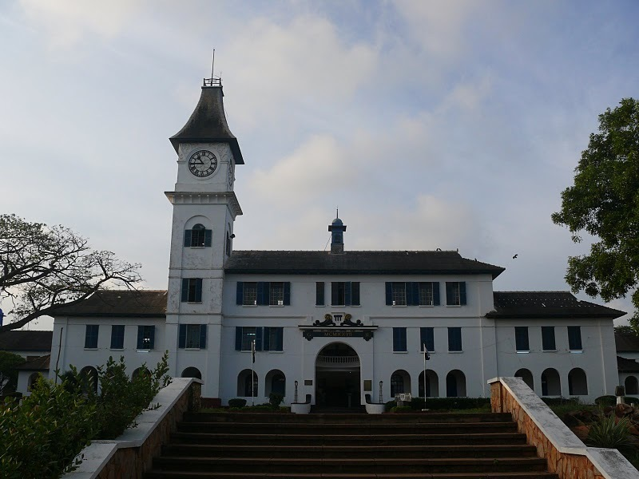

The Administration Block, Achimota School, Accra, Ghana. Photograph taken by author, July 2008.

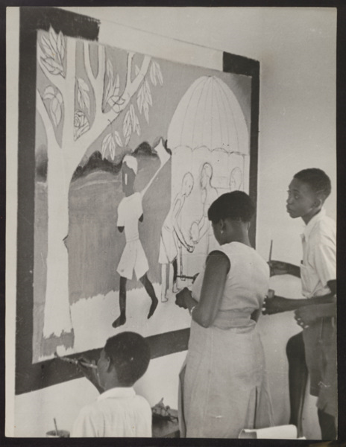

Art students at work at Achimota College in the 1940s, photograph taken by Margot Lubinski. Courtesy of Cambridge University Library/ Institute of Education Collection, reference Y3011U/235.

URL (for reproduction rights): <http://www.lib.cam.ac.uk/deptserv/imagingservices/reproductionrights.html>

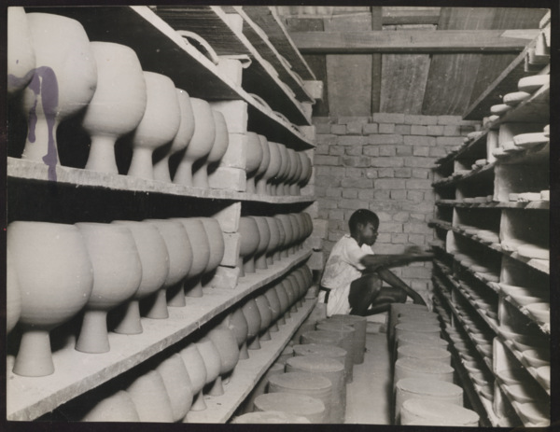

Ceramic Research and pottery at Achimota College in the 1940s, photograph by Margot Lubinski. Courtesy of Cambridge University Library/ Institute of Education Collection, reference Y3011U/236.

URL (for reproduction rights): <http://www.lib.cam.ac.uk/deptserv/imagingservices/reproductionrights.html>

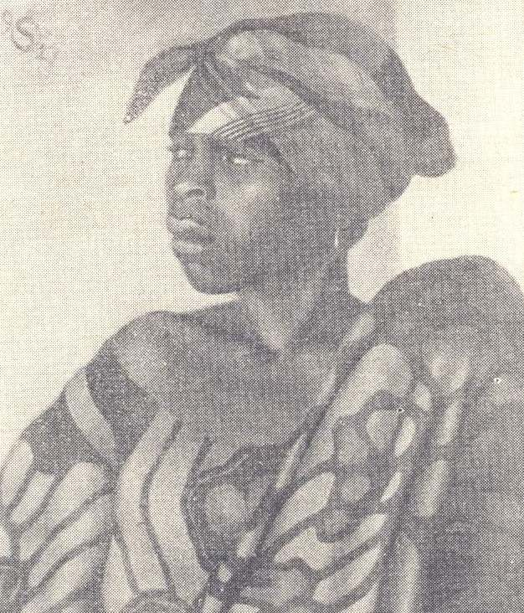

George A. Stevens (Art teacher at Achimota School from 1927-1929), *Portrait of a Fanti girl* (year unknown).

Source: Stevens, George A. (1962), “Go Suku, Savy book and get sense” In: *Listener*, Feb.22, pp. 334-336.